Find the optimal learning rate and the number of iteration.

Process:

1. Find the best PSNR according to the learning rate with the same iteration

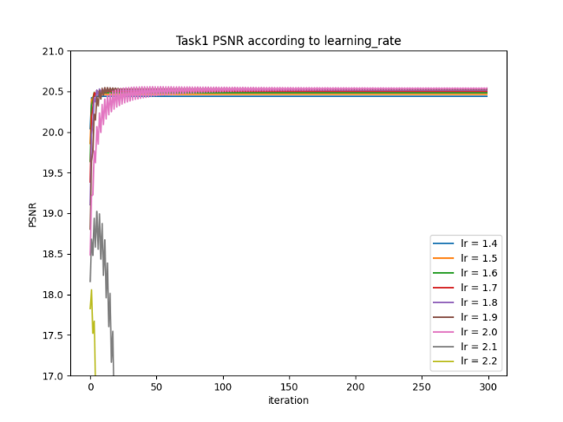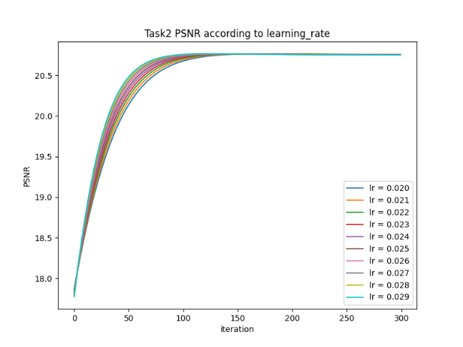

Task 1 :

2. As a result of process 1, with the learning rate of the best PNSR, examine the divergence of PSNR.

